<https://automationstepbystep.com/>

Rest assured:

Rest-Assured is an open-source Java-based library useful for testing and validating REST APIs or RESTFul Web Services. It is like a headless (no GUI) client that accesses and tests the REST Web Services. I

 It has very efficient matching techniques, so asserting your expected results is also pretty straight forward. Rest Assured has methods to fetch data from almost every part of the request and response no matter how complex the JSON structures are.

* It is a java lib (api) for testing rest apis
* To test json and XML web services
* Supports GET, POST,PUT, DELETE, OPTIONS, PATCH , HEAD,
* can be integrated with Testing frameworks like Junit, testNG
* Rest Assured in implemented in groovy

**Check java version ->cmd prompt**

* java -version

**Steps:**

* Open exclipse
* Create maven project
* Add dependences in pom.xml

1. Rest assured io.resrassured
2. TestNG

* Save project
* Add test TestNg plugin
* Create Tests
* Run and verify

**Prerequisites**

* Java
* IDE
* Maven
* TestNG

Summary

* Rest Assured is a group of java libraries which enables us to automate Rest API testing
* Rest Assured is Java-based, and knowledge of core Java suffices for learning it
* It helps fetch values of request and response from complicated JSON structures
* The API request can be customized with a variety of header, query, path param, and any session or cookies to be set.
* It helps set assert statements and conditions.
* While Rest Assured is very helpful when the response is JSON type, it’s methods may not work seamlessly if content type id HTML or plain text.

How to create Request and test for

GET

POST

PUT

PATCH

DELETE

|  |
| --- |
| public void test_1() {  given()  .header("Content-type" , "application/json")  .get("https://reqres.in/api/users?page=2")  .then()  .statusCode(200)  .body("data.id[1]", equalTo(8))  .body("data.first_name", hasItems("Rachel" , "George"))  .log()  .all() ;  }  } |

**Libraries**

* Json
* Jackson
* Gson

**HTTP STATUS**

<https://developer.mozilla.org/en-US/docs/Web/HTTP/Status>

|  |
| --- |
| given()  .header("Content Type", "application/json")  .contentType(ContentType.JSON)  .accept(ContentType.JSON)  .body(request.toJSONString())  .when()  .post("https://reqres.in/api/users")  .then()  .statusCode(201);  = = = = = = = = = = = = = = = = = = = = = = = = = = = = = = = = = = = = = = = = = = = = = = = = = = = = = =  given()  .header("Content Type", "application/json")  .contentType(ContentType.JSON)  .accept(ContentType.JSON)  .body(request.toJSONString())  .when()  .put("https://reqres.in/api/users/2")  .then()  .statusCode(200)  .log()  .all();  = = = = = = = = = = = = = = = = = = = = = = = = = = = = = = = = = = = = = = = = = = = = = = = = = = = = = =  given()  .header("Content Type", "application/json")  .contentType(ContentType.JSON)  .accept(ContentType.JSON)  .body(request.toJSONString())  .when()  .patch("https://reqres.in/api/users/2")  .then()  .statusCode(200)  .log()  .all();  = = = = = = = = = = = = = = = = = = = = = = = = = = = = = = = = = = = = = = = = = = = = = = = = = = = = = =  when()  .delete("https://reqres.in/api/users/2")  .then()  .statusCode(204)  .log()  .all(); |

**How to create a local API server**

**Search for**

Mackoon

Json-server

<https://github.com/typicode/json-server#getting-started>

**Getting started**

**Install JSON Server**

npm install -g json-server

Create a db.json file with some data

|  |
| --- |
| {  "posts": [  { "id": 1, "title": "json-server", "author": "typicode" }  ],  "comments": [  { "id": 1, "body": "some comment", "postId": 1 }  ],  "profile": { "name": "typicode" }  } |

**Start JSON Server**

json-server --watch db1.json

**Output**

Resources

http://localhost:3000/posts

http://localhost:3000/comments

http://localhost:3000/profile

Home

http://localhost:3000

**Next lauch the browser**

<http://localhost:3000/>

<http://localhost:3000/comments>

When learning web development and HTTP specification, it is not unlikely to find yourself getting confused about the type of verb to use, and when to use it. With most applications on the internet being CRUD (create, read/retrieve, updates, delete), developers must learn how to match HTTP verbs to these actions. Typically, the verbs and actions are matched as follows:

POST – Create

GET – Read/Retrieve

PUT/PATCH – Update

DELETE – Delete

**What is PUT?**

PUT is a method of modifying resource where the client sends data that updates the entire resource. It is used to set an entity’s information completely. PUT is similar to POST in that it can create resources, but it does so when there is a defined URI. PUT overwrites the entire entity if it already exists, and creates a new resource if it doesn’t exist.

For example, when you want to change the first name of a person in a database, you need to send the entire resource when making a PUT request.

{“first": "John", "last": "Stone”}

To make a PUT request, you need to send the two parameters; the first and the last name.

Blog » The Dev Room » What’s the Difference between PUT vs PATCH?

What’s the Difference between PUT vs PATCH?

By RapidAPI Staff // April 16, 2021

Table of Contents [show]

**PUT vs PATCH**

When learning web development and HTTP specification, it is not unlikely to find yourself getting confused about the type of verb to use, and when to use it. With most applications on the internet being CRUD (create, read/retrieve, updates, delete), developers must learn how to match HTTP verbs to these actions. Typically, the verbs and actions are matched as follows:

POST – Create

GET – Read/Retrieve

PUT/PATCH – Update

DELETE – Delete

From this mapping, it is not surprising that most people think that PUT and PATCH are allies that do the same thing. However, the reality is far more complex, especially when it comes to overlapping functionality and other complications. Actually, PUT and PATCH might be doing the same thing of updating a resource at a location, but they do it differently. Therefore, to understand more about these verbs, let’s dive deep into HTTP specification and identify the subtle differences between the two.

**What is PUT?**

PUT is a method of modifying resource where the client sends data that updates the entire resource. It is used to set an entity’s information completely. PUT is similar to POST in that it can create resources, but it does so when there is a defined URI. PUT overwrites the entire entity if it already exists, and creates a new resource if it doesn’t exist.

For example, when you want to change the first name of a person in a database, you need to send the entire resource when making a PUT request.

{“first": "John", "last": "Stone”}

To make a PUT request, you need to send the two parameters; the first and the last name.

**What is PATCH?**

Unlike PUT, PATCH applies a partial update to the resource.

This means that you are only required to send the data that you want to update, and it won’t affect or change anything else. So if you want to update the first name on a database, you will only be required to send the first parameter; the first name.

**What is TestNG dataprovider?**

Helps to write data driven test

Same tests can be run multiple times with different sets of data.

Annotation @dataProvider

The annoted method is used to return object containing test data

This test data can be used in actual tests

**@Parameters**

**To create TestNG.xml file**

Select the class-> Right click 🡪 TestNG 🡪 convert to TestNG

**Data driven testing using excel files**

Step 1 : Add maven dependency for excel reading and writing

Step 2 : Create a folder and add excel file and create data in the file

Step 3 : Create a class and create functions to get row count

Step 4 : Create a function to get data from excel

Step 5 : Create a constructor to get excelPath and sheetName

Step 6 : Create a new class and call the excel functions

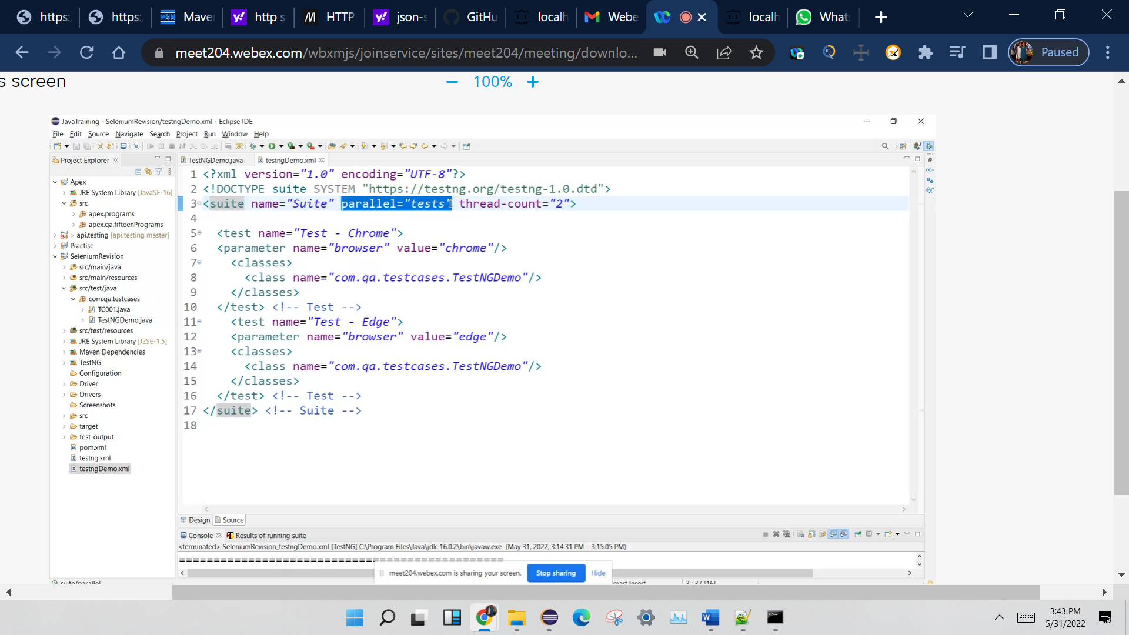

**API Testing**

**1) What is API?**

API (Application Programming Interface) helps in communication and data exchange between two software systems. API act as an interface between two applications and allows the two software systems communicate with one another. API is a collection of functions which can be executed by another software program.

API works as; it takes a request from the source, takes that request to the database, fetches the request data from the database and returns a response to the source. API takes the requests from the user and gives the response without exposing the internal details. API acts as Abstraction.

**2) What is API testing?**

API testing is a type of software testing that involves testing APIs directly. API is a part of integration testing to check whether the API meets expectations in terms of functionality, reliability, performance, and security of applications. Multiple API system can performed API testing. In API testing, our primary focus is on Business Logic Layer of the software architecture.

**3) What are the types of API testing?**

API testing involves the following types of testing:

Unit Testing

Functional Testing

Load Testing

Runtime/Error Detection

Security Testing

UI Testing

Interoperability and WS compliance Testing

Penetration Testing

Fuzz Testing

**4) What are the protocols used in API Testing?**

Protocols used in API testing are:

HTTP

REST

SOAP

JMS

UDDI

**5) What are the tools used for API Testing?**

Tools used for API testing are:

Parasoft SOAtest

PostMan

AlertSite API monitoring

Naveen Automation Labs

API are used when two systems are interactingwith each other.

<https://www.youtube.com/watch?v=LUbBkiIhrE4&list=PLFGoYjJG_fqp891lruz5fCRPWsDtEXJky>

WebServices : (MakemyTrip.com)

Api – Web Services 🡺HTTP/network

**Request payload**: In APIs, the payload is the data contained within a request.

Response JSON: Response to a API in JSON format

Response XML: Response to a API in XML format

Authentication : Session/Token ID

Username/ password

Request -JSON/XML

HTTP method – CRUD

SOAP: Simple Object Access Protoco : is a protocoll

Rest : REpresentational State Transfer : is architectural style

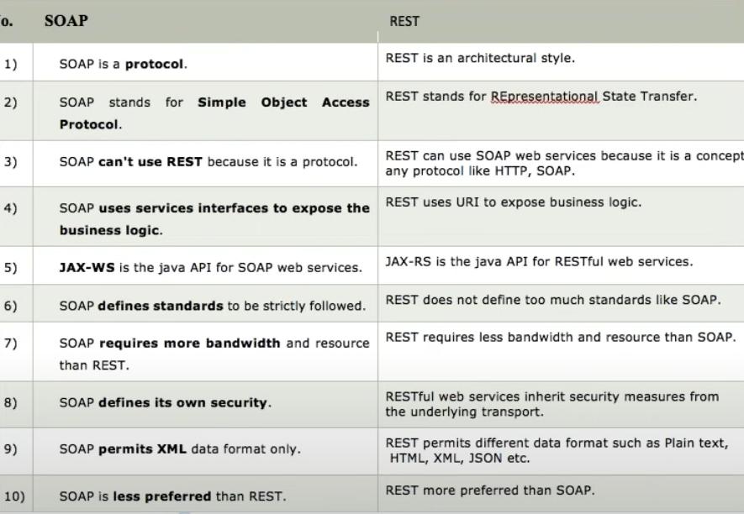

**Rest webservices Automation**

What is Rest Client

HTTP Request = URI +Header + payload (JSON/XML)

HTTP Response = Status + Response payload +String message (successful)

Create Account 🡺POST call 🡺 used to create a new entity 🡺Header +payload

Get an account 🡺GET call 🡺 URI + Path parameter + Query parameter + header

Update account 🡺PUT call 🡺create+ update

Delete Account 🡺DELETE call 🡺

URI = Path parameter +query parameter

HTTP status response codes

<https://developer.mozilla.org/en-US/docs/Web/HTTP/Status>

Status Response code 🡺

200= ok

201 = Created successfully

400 = Bad request

401 = Authentication error

404 = Not found

500 = Server internal error

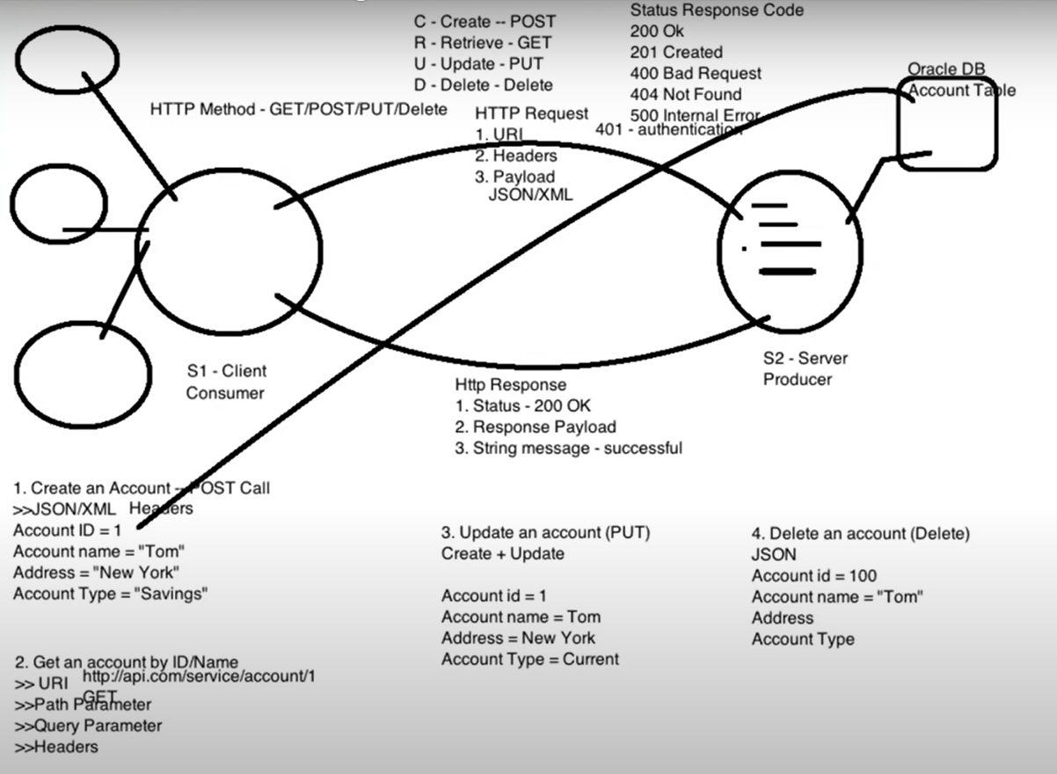

What is postman?

It is a Rest client.

SOAP UI, Advanced Rest Client, JMeter , browser

URL (Endpoint URL + API/Service URL) = URI

Query Paramenter is defined by ?

Path parameter is defined by /

What Is Swagger?

Swagger allows you to describe the structure of your APIs so that machines can read them. The ability of APIs to describe their own structure is the root of all awesomeness in Swagger.

<https://fakerestapi.azurewebsites.net/index.html>

Swagger: Api documentation

Step1

Create maven project

Add dependancies

http client

http core

JSON In Java

TestNG

CloseableHttpResponse : is a Interface

|  |
| --- |
| HttpClients.createDefault() : Create one client connection and returns CloseableHTTPclient object.  **CloseableHttpClient** is the base class of the **httpclient** library, the one all implementations use. |
| HttpGet() : is a class |
| httpClient.execute(httpGet); executes a request or hits the api and returns closeable HTTPResponse |
| httpResponse.getEntity() : Obtains the message entity of this response, if any.The entity is provided by calling setEntity.Returns:the response entity, or null if there is none |
| EntityUtils.toString(httpResponse.getEntity(), "UTF-8" );  EntitiUtils : Static helpers for dealing with [HttpEntity](eclipse-javadoc:%E2%98%82=restapi/C:%5C/Users%5C/TISHAN1KA%5C/.m2%5C/repository%5C/org%5C/apache%5C/httpcomponents%5C/httpcore%5C/4.4.7%5C/httpcore-4.4.7.jar=/maven.pomderived=/true=/=/maven.pomderived=/true=/=/maven.groupId=/org.apache.httpcomponents=/=/maven.artifactId=/httpcore=/=/maven.version=/4.4.7=/=/maven.scope=/compile=/%3Corg.apache.http.util(EntityUtils.class%E2%98%83EntityUtils%E2%98%82HttpEntity)s. |
| JSON obj = new JSONObject(responseString)  Converts Response to JSON Object |
|  |
|  |
|  |
|  |
|  |
|  |
|  |
|  |
|  |

**HTTP Client**

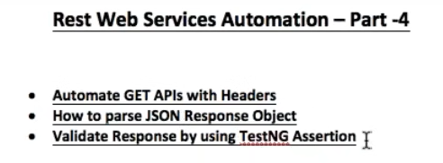

POJO class

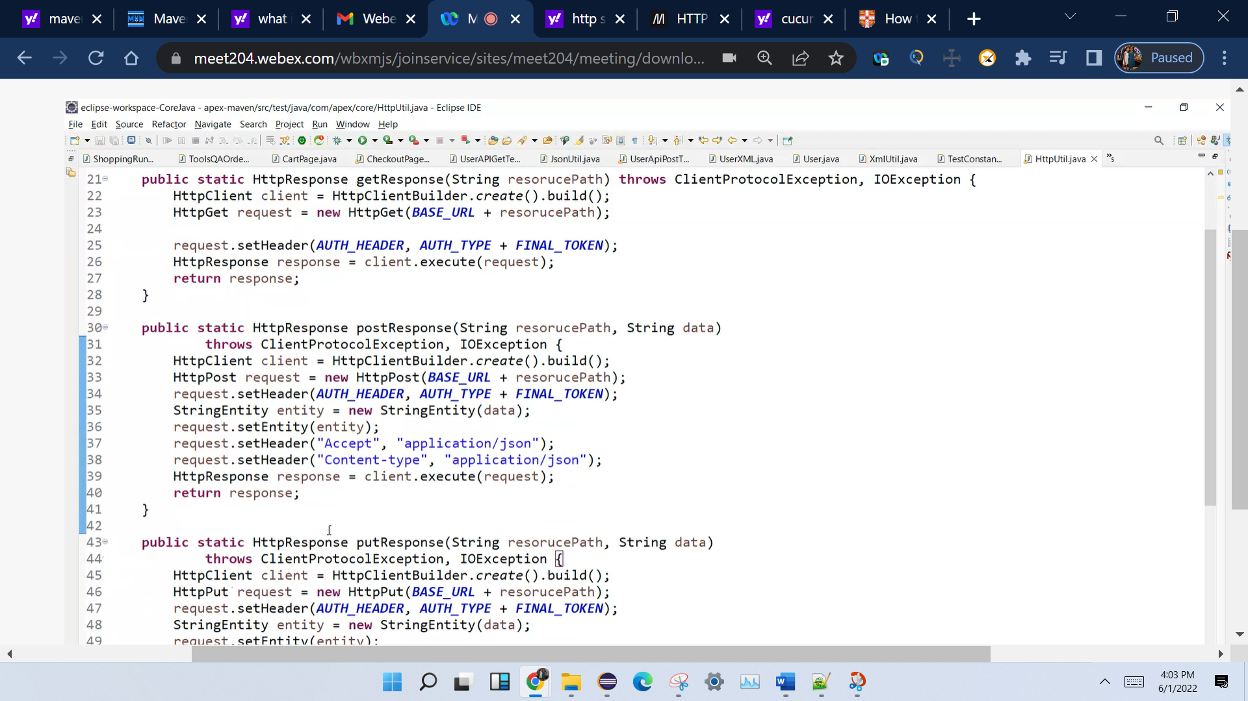

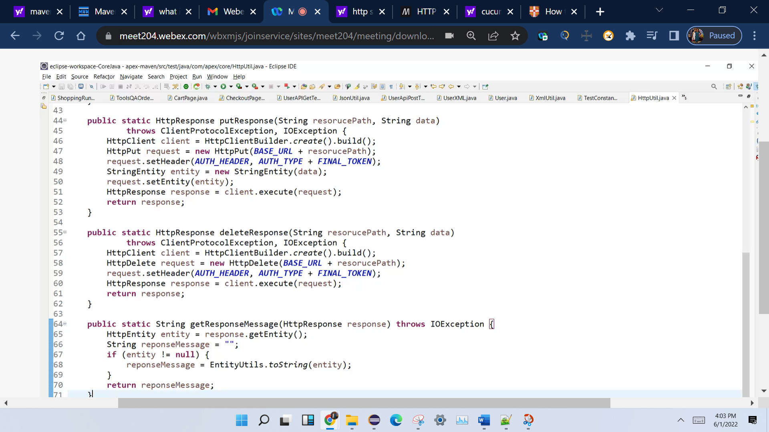

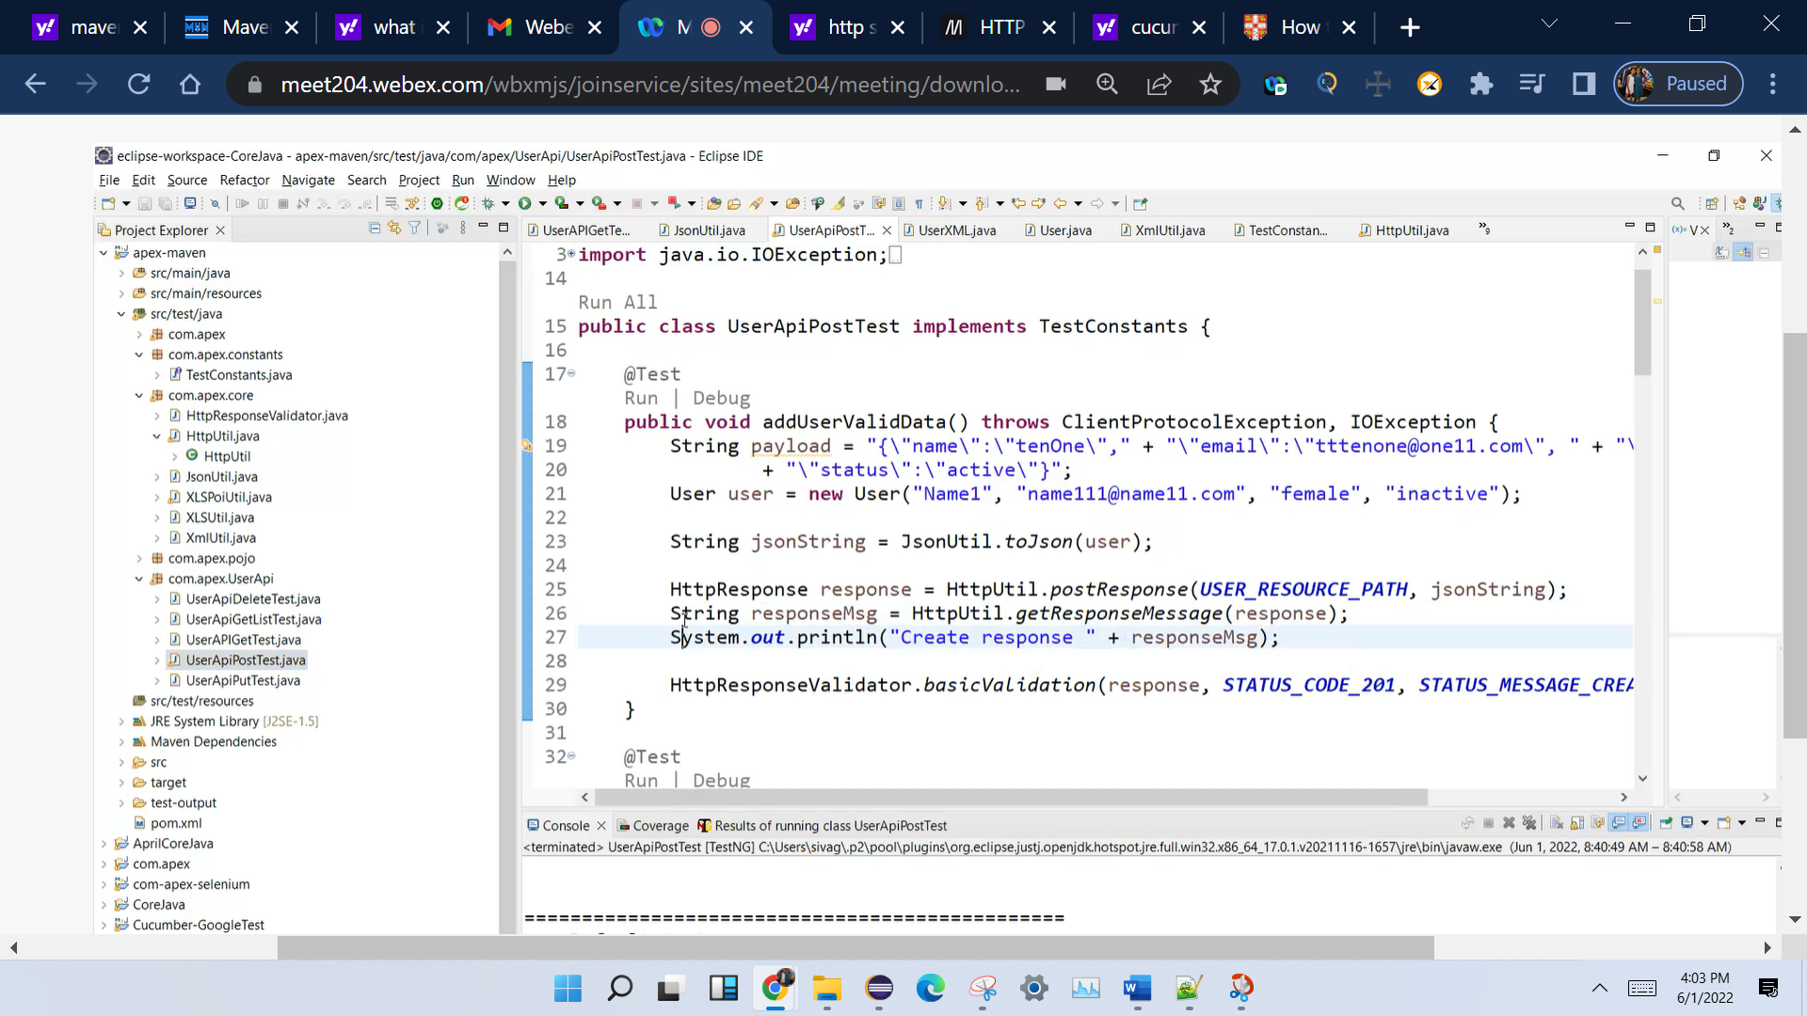

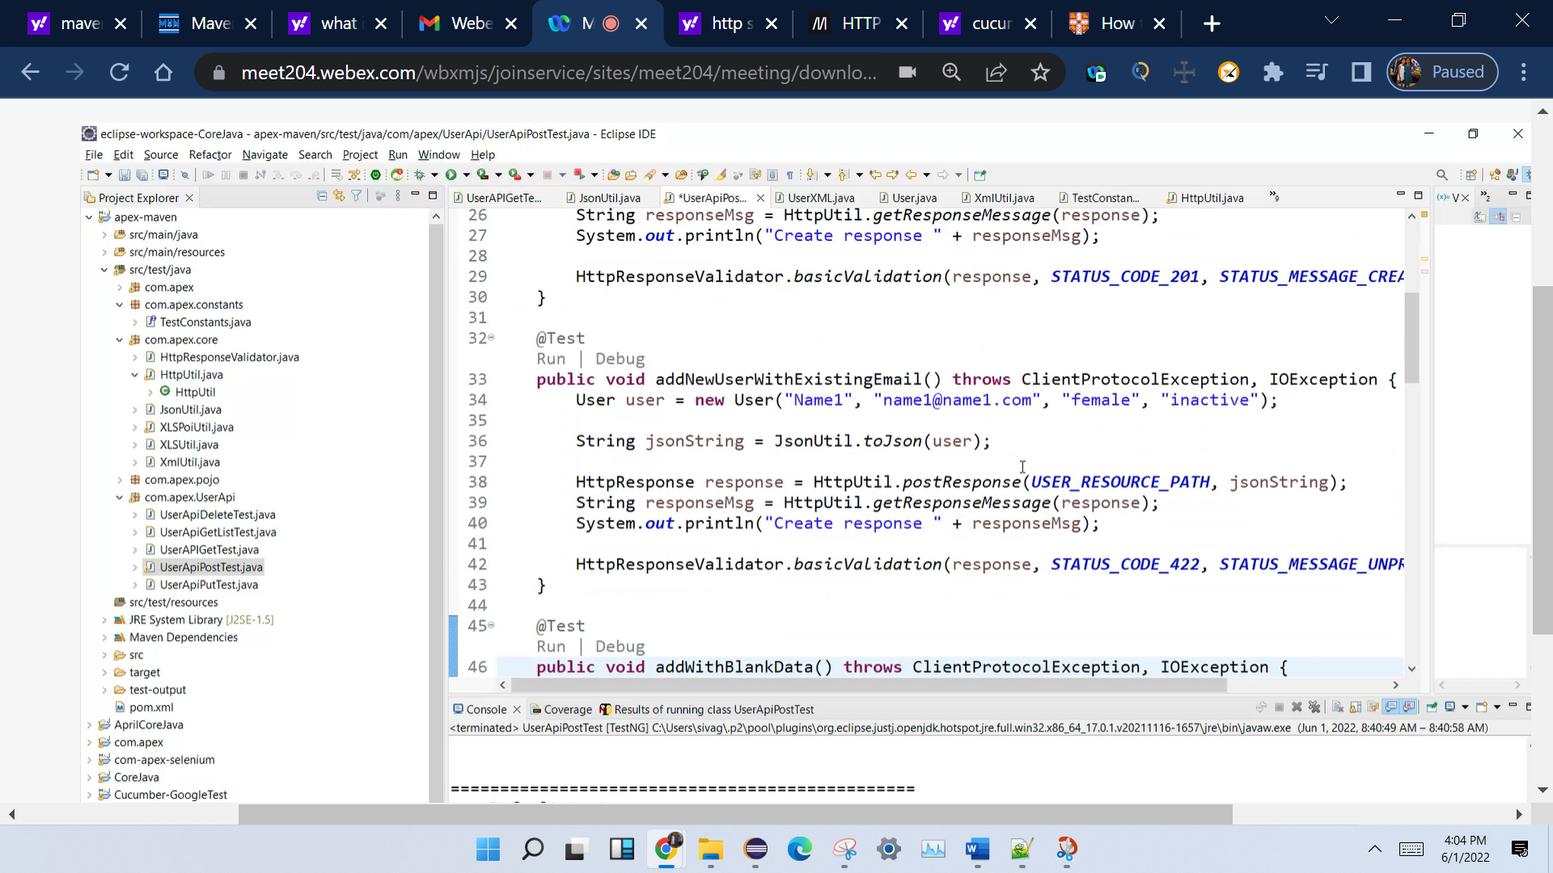

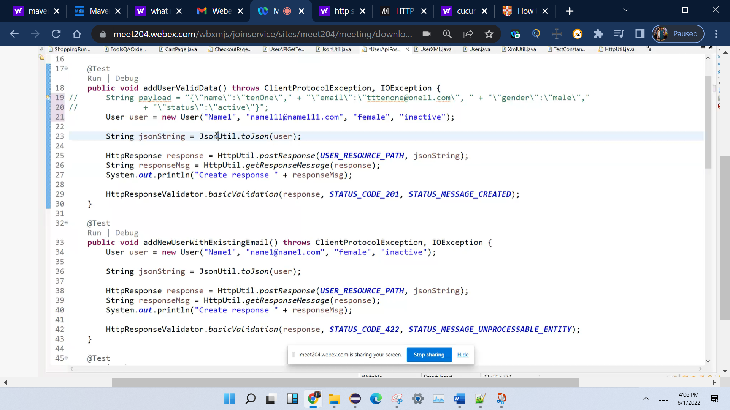

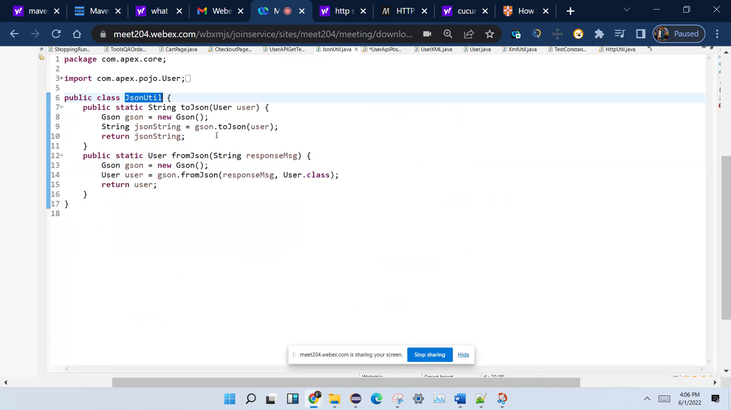

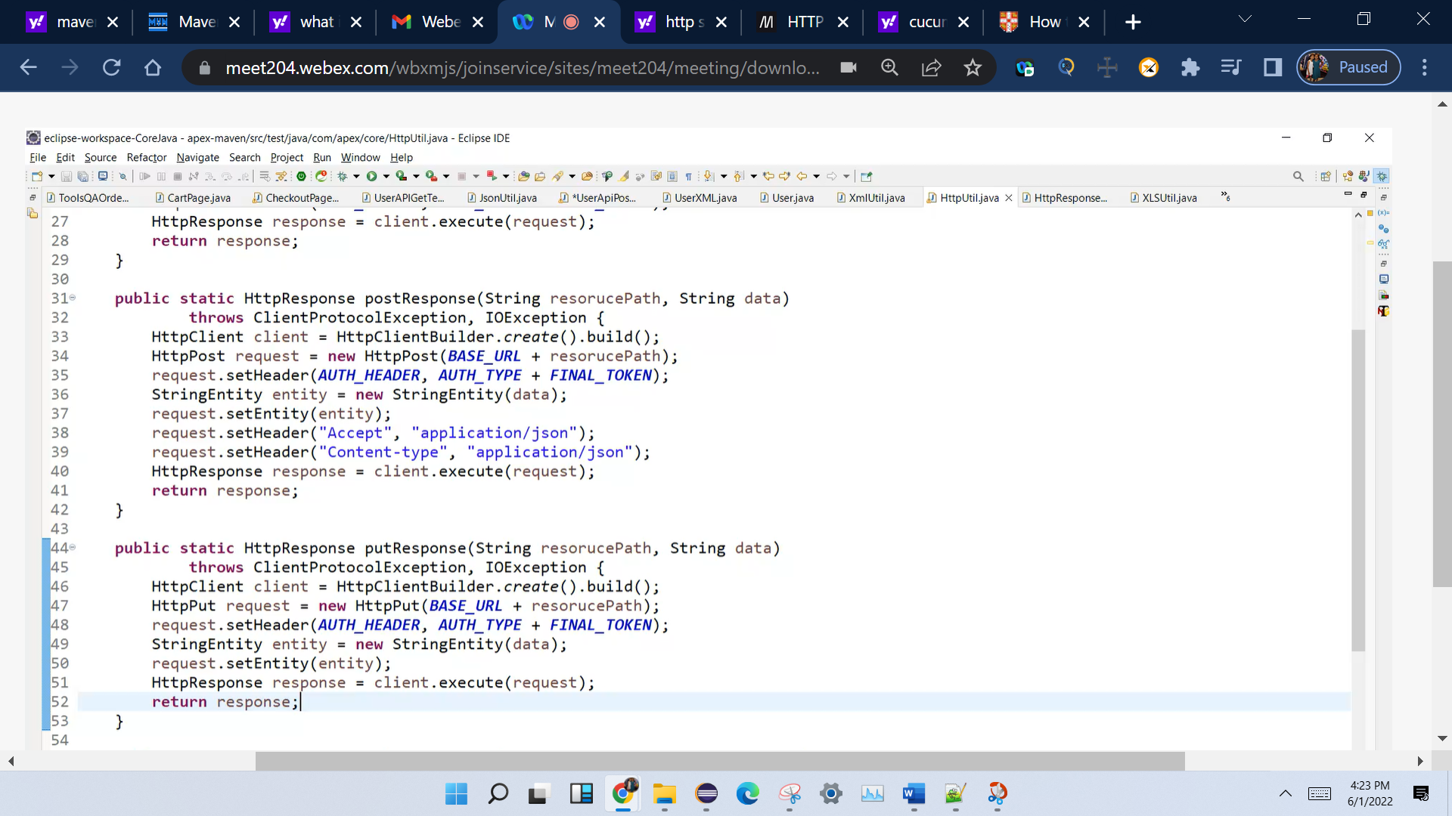

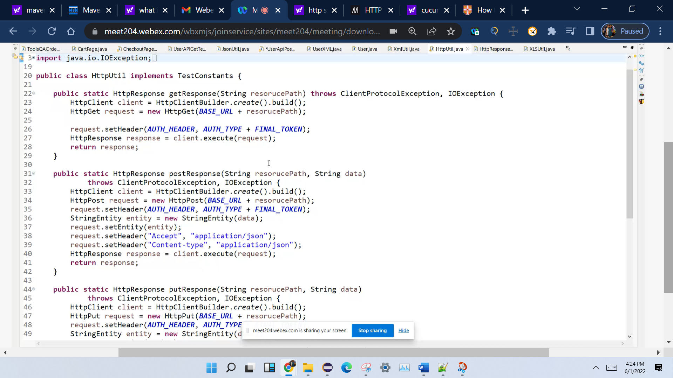

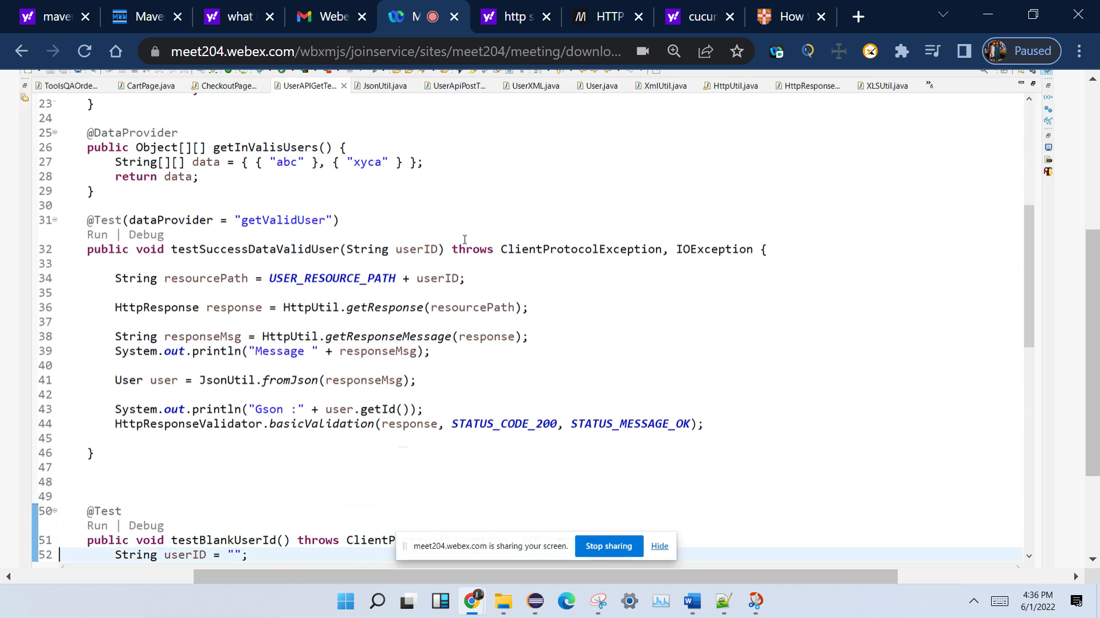

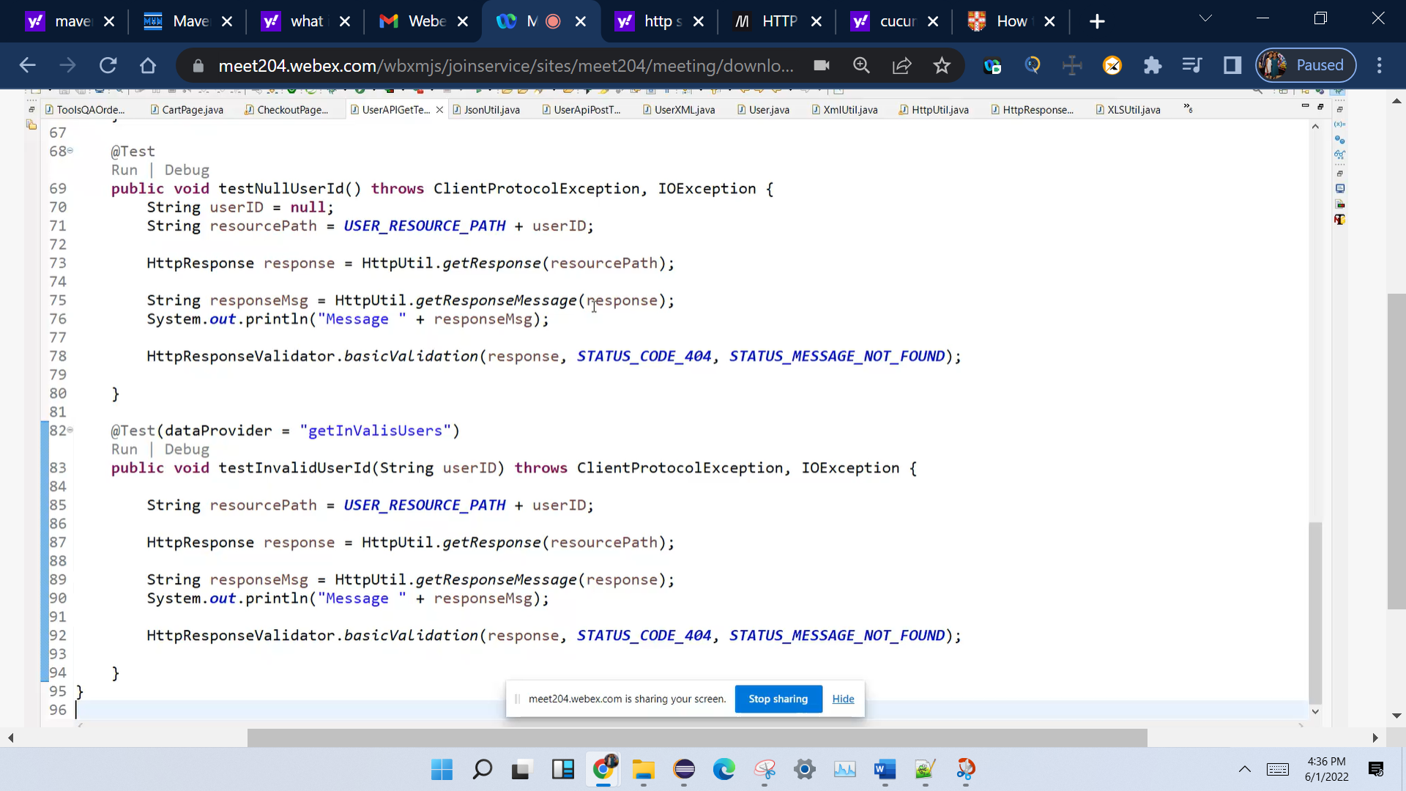

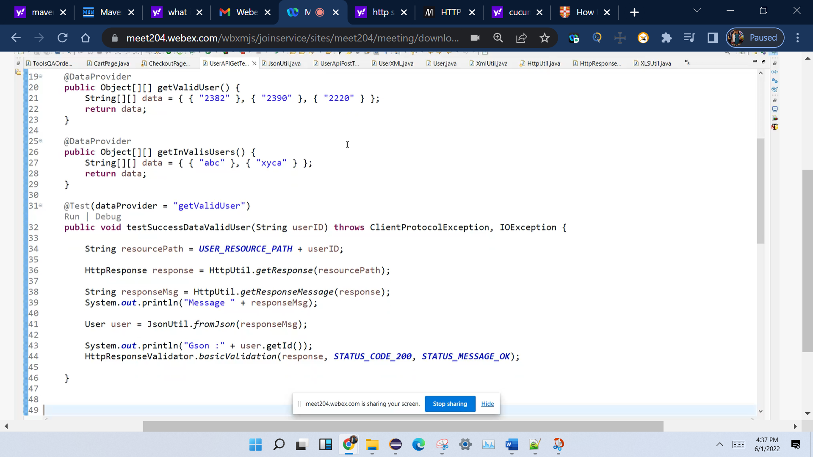

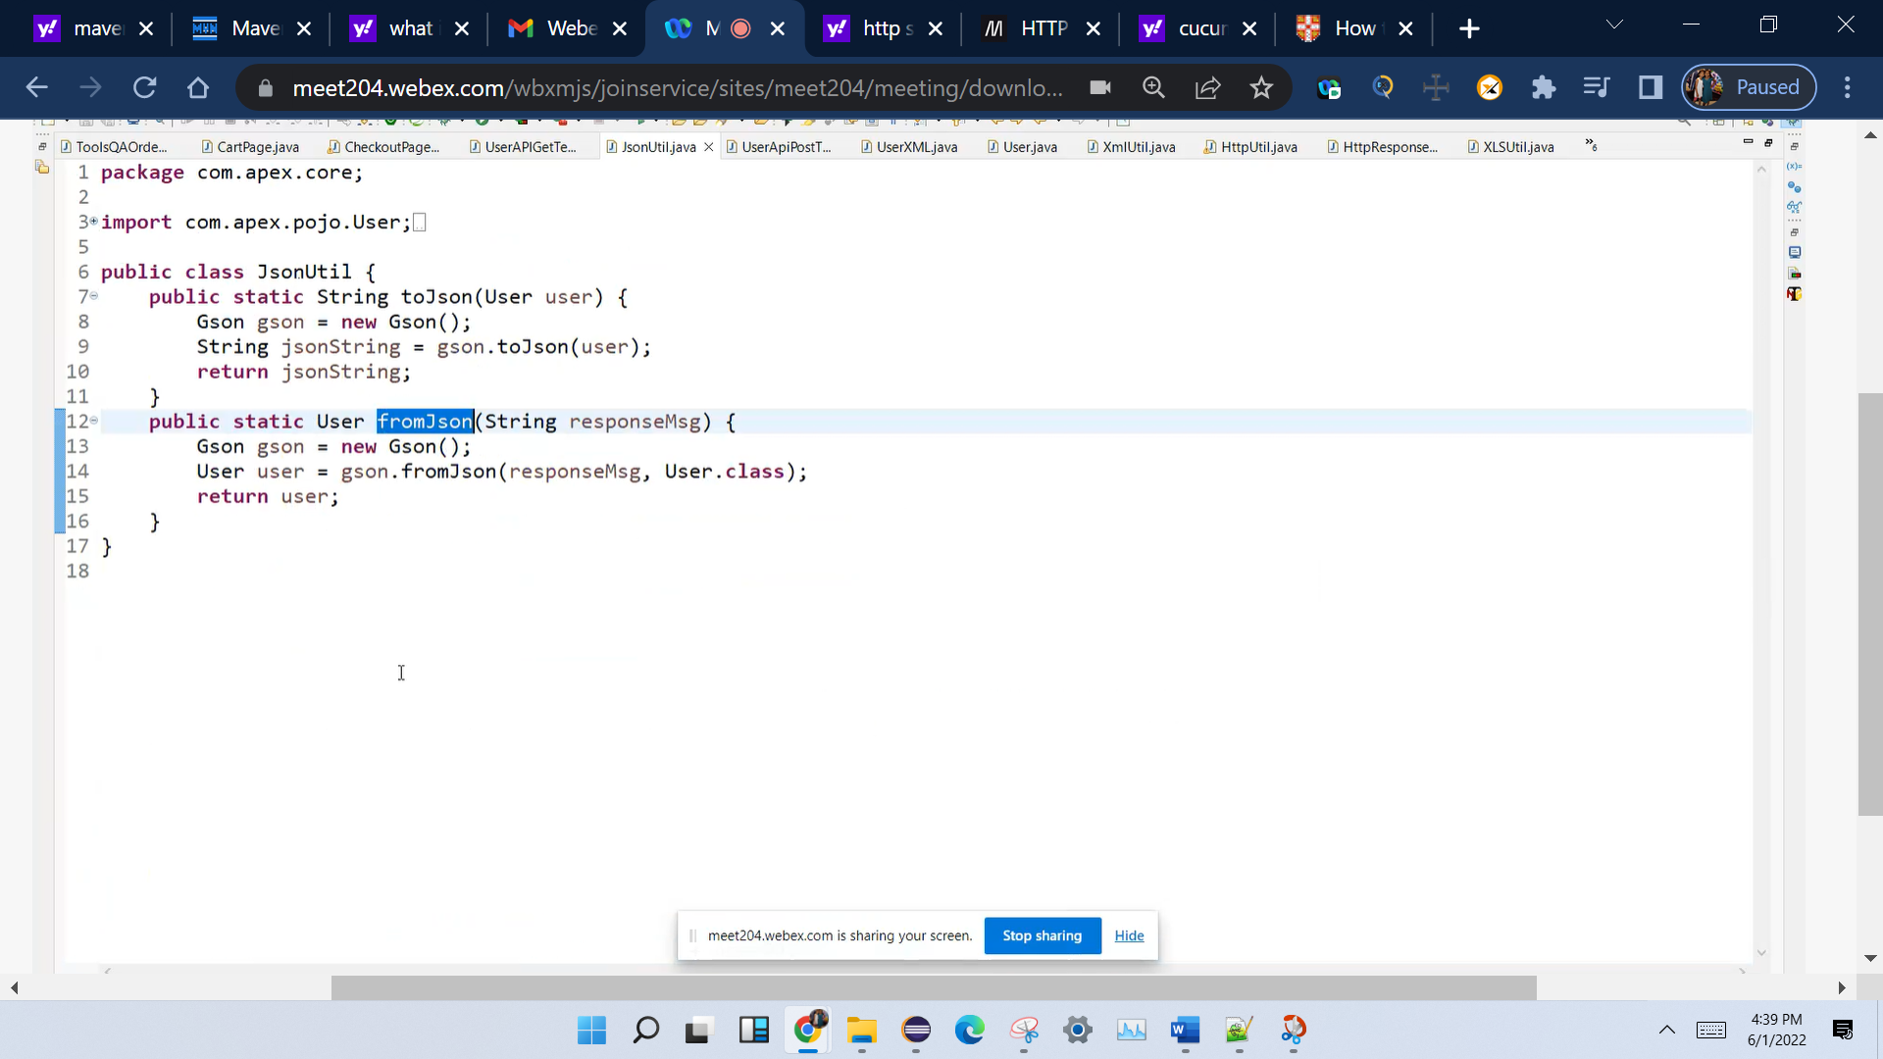

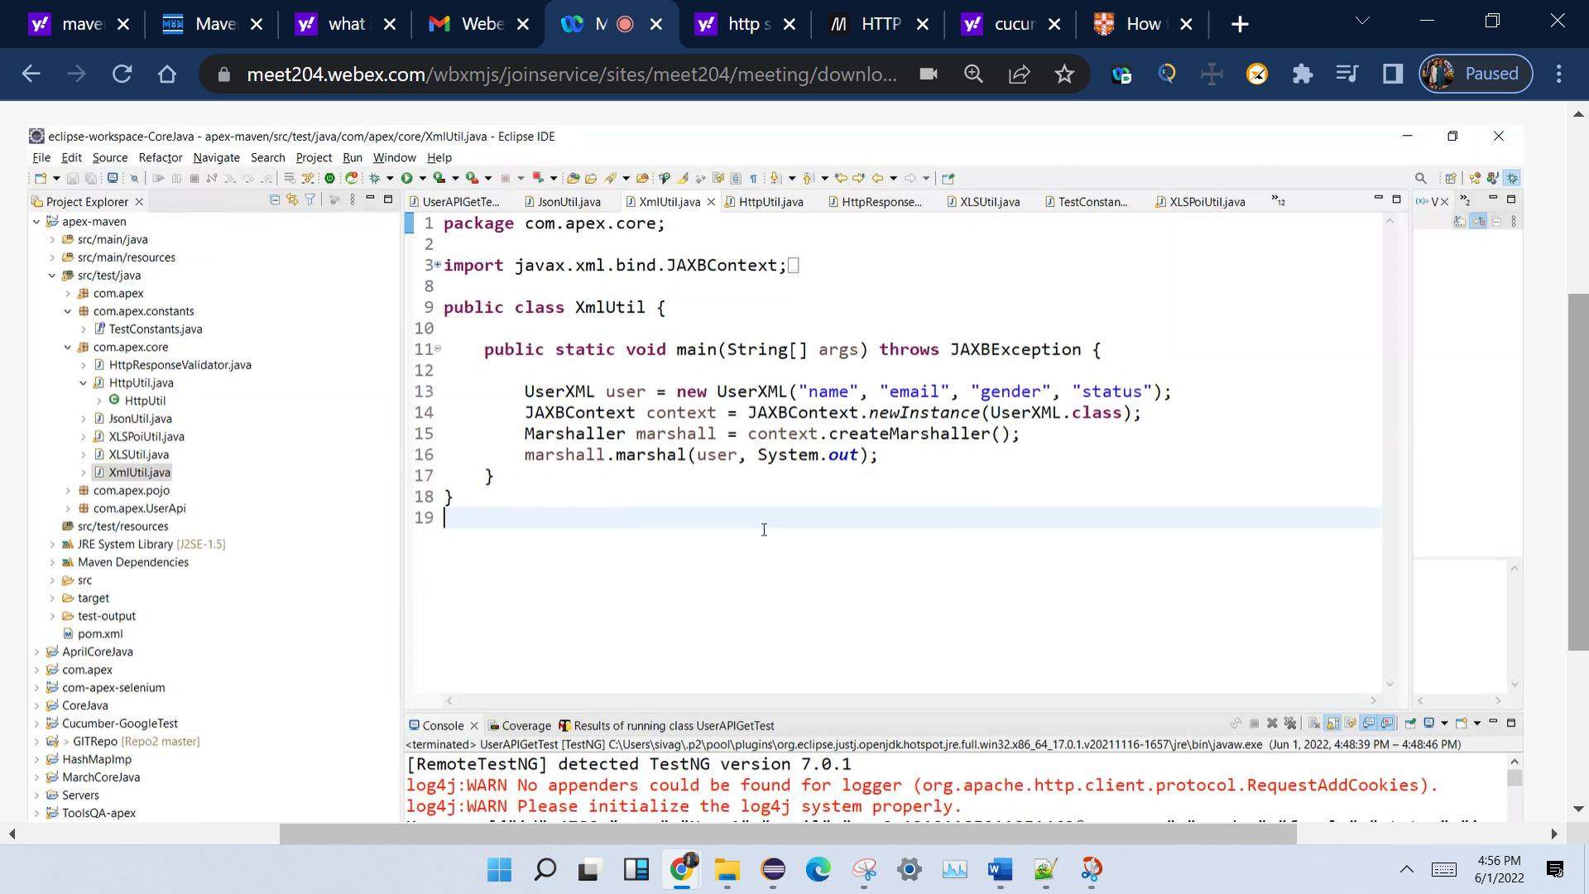

Marsheller vs unmarshalling